# Spring sample app with Running Test case on Service layer

## Configuration

1. Open Pom.xml - Make sure **maven.test.skip** should be “false”



1. Open src/java/resources/application-h2db.properties

Create folder for h2db and set to below configuration

spring.datasource.url=jdbc:h2:file:***<h2 db folder path>***

1. Compile project:

mvn compile

1. Run Unit test

You can find test class in package “”  
  
Run unit test case from cmd

mvn test

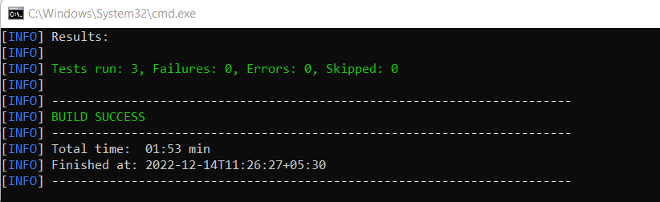

1. Build project and generate jar file.

mvn clean install

* With Test case : Make sure **maven.test.skip** should be “false”



*Make sure your all test cases should get passed and No one test case should not get failed or should throw any error.*

* With Test case : Make sure **maven.test.skip** should be “true”

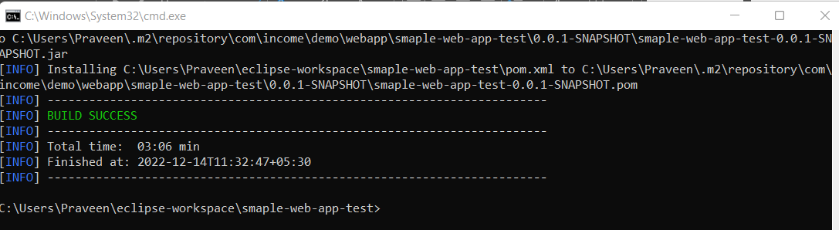

## App Description:

1. Entity – Customers
   * + Name – Required element
     + Phone - Required element
     + Email - Required element
     + Address – Optional element
     + Zipcode - Optional element
     + Id – Identity element (Auto incremental)

Here “Required element” are need to be provided for Customers entity while saving in database.

Here “Optional element” are not necessary to be provided for Customer entity while saving in database.

Here Identity element (Auto incremental) is an identity of customers entity , it will automatically get inserted while adding new customer data.

1. Service – CustomerService

Having several methods for operating Customer entity

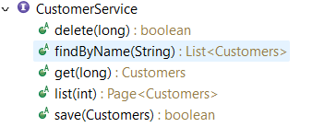

1. Spring Test – CustomersServiceTest

We have defined test method to test service.

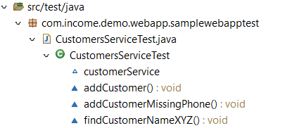

Here customerService variable is getting injected from CustomerService by @Autowired.